Technical Design Document: Local-First RAGOps Platform

1. Purpose
We will build a local-first RAGOps platform for document ingestion, retrieval, answer generation, evaluation, semantic caching, model routing, arbitration, and automated documentation updates.
The system will use fully free and open-source/local-first components and will not depend on paid LLM APIs, paid hosted inference, paid vector databases, paid evaluation services, or paid observability platforms.

2. System Scope
The platform will support the following capabilities:
- Document ingestion
- Text extraction and parsing
- Chunking and metadata enrichment
- Embedding generation
- Vector indexing and retrieval
- Answer generation with citations
- Retrieval trace inspection
- Model routing
- RAG evaluation
- Semantic caching
- Output arbitration
- Automated documentation updates from code changes
- Static reporting and project documentation publishing

3. Target Architecture
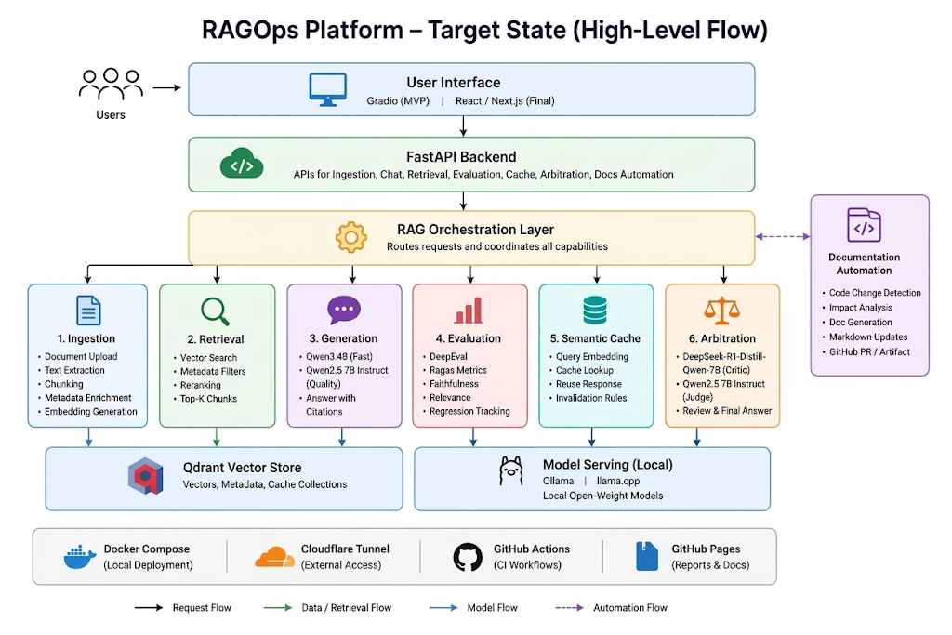

4. Core Technology Stack
Layer | Technology
Backend API | FastAPI
MVP Interface | Gradio
Final Interface | React / Next.js
Model Serving | Ollama
Advanced Model Serving | llama.cpp
Vector Store | Qdrant
Main Generation Model | Qwen3 4B
Quality Generation Model | Qwen2.5 7B Instruct
Reasoning Critic Model | DeepSeek-R1-Distill-Qwen-7B
Main Embedding Model | nomic-embed-text-v1.5
Cache Embedding Model | bge-small-en-v1.5
Reranker | MiniLM first, bge-reranker-v2-m3 later
Evaluation Frameworks | DeepEval and Ragas
Code Documentation Model | Qwen2.5-Coder 7B
CI Documentation Fallback | StarCoder2 3B
Local Deployment | Docker Compose
External Demo Access | Cloudflare Tunnel
Static Reports and Docs | GitHub Pages
CI Workflow | GitHub Actions

5. Reference Links
Component | Official Link
FastAPI | https://fastapi.tiangolo.com/
Gradio | https://www.gradio.app/docs
React | https://react.dev/
Next.js | https://nextjs.org/docs
Ollama | https://github.com/ollama/ollama
Ollama Docs | https://github.com/ollama/ollama/tree/main/docs
llama.cpp | https://github.com/ggml-org/llama.cpp
Qdrant | https://qdrant.tech/documentation/
Docker Compose | https://docs.docker.com/compose/
GitHub Actions | https://docs.github.com/en/actions
GitHub Pages | https://docs.github.com/en/pages
Cloudflare Tunnel | https://developers.cloudflare.com/cloudflare-one/connections/connect-networks/
Qwen3 4B | https://huggingface.co/Qwen/Qwen3-4B
Qwen2.5 7B Instruct | https://huggingface.co/Qwen/Qwen2.5-7B-Instruct
DeepSeek-R1-Distill-Qwen-7B | https://huggingface.co/deepseek-ai/DeepSeek-R1-Distill-Qwen-7B
nomic-embed-text-v1.5 | https://huggingface.co/nomic-ai/nomic-embed-text-v1.5
bge-small-en-v1.5 | https://huggingface.co/BAAI/bge-small-en-v1.5
MiniLM Reranker | https://huggingface.co/cross-encoder/ms-marco-MiniLM-L-6-v2
bge-reranker-v2-m3 | https://huggingface.co/BAAI/bge-reranker-v2-m3
DeepEval | https://docs.confident-ai.com/
Ragas | https://docs.ragas.io/
Qwen2.5-Coder 7B | https://huggingface.co/Qwen/Qwen2.5-Coder-7B-Instruct
StarCoder2 3B | https://huggingface.co/bigcode/starcoder2-3b

6. Stage 1: Core RAG MVP

Objective
We will build the first working version of the RAG pipeline.

Stack
Area | Technology
Backend | FastAPI
UI | Gradio
Model Serving | Ollama
Generation Model | Qwen3 4B
Embedding Model | nomic-embed-text-v1.5
Vector Store | Qdrant
Deployment | Docker Compose

Deliverables
- Document upload API
- Text extraction pipeline
- Chunking pipeline
- Embedding generation
- Qdrant indexing
- Similarity retrieval
- Answer generation
- Citation display
- Basic request and response logging
- Configuration-driven model and retrieval settings

7. Stage 2: Retrieval Inspection and Quality Layer

Objective
We will add retrieval debugging, source inspection, and higher-quality generation.

Stack Additions
Area | Technology
Quality Model | Qwen2.5 7B Instruct
Reranker | cross-encoder/ms-marco-MiniLM-L-6-v2
Retrieval Store | Qdrant metadata filters

Deliverables
- Retrieved chunk viewer
- Similarity score display
- Citation inspection panel
- Prompt and context preview
- Retrieval trace logging
- Quality mode using Qwen2.5 7B
- Optional reranking step

8. Stage 3: Documentation Automation

Objective
We will build an automated documentation update workflow based on code changes.

Stack Additions
Area | Technology
Local Code Documentation Model | Qwen2.5-Coder 7B
CI Fallback Model | StarCoder2 3B
CI Workflow | GitHub Actions
Documentation Output | Markdown

Deliverables
- Changed-file detector
- FastAPI route-change detector
- Configuration and schema-change detector
- Documentation impact mapper
- Markdown patch generator
- Pull request comment or documentation artifact
- Local/self-hosted execution path for heavier documentation generation

9. Stage 4: Evaluation Engine

Objective
We will add automated RAG quality evaluation and regression tracking.

Stack Additions
Area | Technology
Evaluation Framework | DeepEval
RAG Metrics | Ragas
Judge Model | Qwen2.5 7B Instruct
Static Reports | GitHub Pages

Evaluation Dimensions
- Faithfulness
- Citation support
- Context precision
- Context recall
- Answer relevance
- Answer completeness
- Hallucination risk
- Regression pass/fail status

Deliverables
- Evaluation dataset format
- Local judge integration
- RAGAS metric pipeline
- DeepEval regression tests
- JSON evaluation output
- Static HTML/Markdown reports
- GitHub Pages publishing workflow

10. Stage 5: Multi-Model Routing and Semantic Cache

Objective
We will add model selection, response reuse, and cache-aware generation.

Stack Additions
Area | Technology
Fast Model | Qwen3 4B
Quality Model | Qwen2.5 7B Instruct
Cache Store | Qdrant collection
Cache Embedding Model | bge-small-en-v1.5

Cache Metadata
Each cache entry will store:
- Query embedding
- Model name
- Quantization profile
- System prompt version
- Prompt template version
- Retriever configuration version
- Reranker configuration version
- Corpus hash
- Generation parameters
- Created timestamp
- Expiry policy

Deliverables
- Model selector
- Model routing layer
- Qdrant semantic cache collection
- Cache lookup pipeline
- Cache invalidation rules
- Cache hit/miss logging
- Cache inspection view

11. Stage 6: Output Arbitration

Objective
We will add a review layer for difficult, low-confidence, or high-risk responses.

Stack Additions
Role | Model
Generator | Qwen2.5 7B Instruct
Critic | DeepSeek-R1-Distill-Qwen-7B
Judge | Qwen2.5 7B Instruct

Arbitration Triggers
- Low retrieval confidence
- Conflicting retrieved sources
- Weak citation support
- Failed evaluation threshold
- High-risk query category
- Explicit deep-review mode

Deliverables
- Arbitration router
- Critic prompt template
- Judge prompt template
- Structured arbitration output
- Retry or rewrite workflow
- Arbitration trace logging
- Arbitration result display in UI

12. Final Application Structure
ragops-platform/
│
├── backend/
│ ├── api/
│ ├── ingestion/
│ ├── retrieval/
│ ├── generation/
│ ├── evaluation/
│ ├── caching/
│ ├── arbitration/
│ └── docs_automation/
│
├── frontend/
│ ├── gradio_app/
│ └── web_app/
│
├── configs/
│ ├── models.yaml
│ ├── retrieval.yaml
│ ├── prompts.yaml
│ └── evaluation.yaml
│
├── evals/
│ ├── datasets/
│ ├── reports/
│ └── regression_tests/
│
├── docs/
│ ├── architecture/
│ ├── api/
│ ├── operations/
│ └── evaluation_reports/
│
├── deployment/
│ ├── docker-compose.yml
│ ├── cloudflare_tunnel.md
│ └── github_pages.md
│
└── .github/
└── workflows/

13. Final Build Plan
Stage | Build Area | Primary Outcome
Stage 1 | Core RAG MVP | Working document-based question answering
Stage 2 | Retrieval Quality | Inspectable retrieval and quality generation
Stage 3 | Documentation Automation | Code-change-driven documentation updates
Stage 4 | Evaluation Engine | Automated RAG scoring and regression reports
Stage 5 | Multi-Model and Cache | Model routing and semantic response reuse
Stage 6 | Arbitration | Reviewed and higher-confidence final responses

14. Final Target Stack
Area | Selected Stack
Backend API | FastAPI
Initial UI | Gradio
Final UI | React / Next.js
Model Serving | Ollama, llama.cpp
Vector Store | Qdrant
Main Generation Model | Qwen3 4B
Quality Generation Model | Qwen2.5 7B Instruct
Reasoning Critic Model | DeepSeek-R1-Distill-Qwen-7B
Main Embedding Model | nomic-embed-text-v1.5
Cache Embedding Model | bge-small-en-v1.5
Initial Reranker | cross-encoder/ms-marco-MiniLM-L-6-v2
Advanced Reranker | bge-reranker-v2-m3
Evaluation Frameworks | DeepEval, Ragas
Documentation Model | Qwen2.5-Coder 7B
CI Documentation Fallback | StarCoder2 3B
Local Deployment | Docker Compose
External Demo Access | Cloudflare Tunnel
Static Reports and Documentation | GitHub Pages
CI Workflow | GitHub Actions

